Practical lesson 18: Microbiological diagnosis of mycoses.
Because fungi (yeasts and molds) are eukaryotic organisms, whereas bacteria are prokaryotic, they differ in several fundamental respects. Two fungal cell structures are important medically:(1) The fungal cell wall consists primarily of chitin (not peptidoglycan as in bacteria); thus fungi are insensitive to certain antibiotics, such as penicillins and cephalosporins, that inhibit peptidoglycan synthesis. (2) Chitin is a polysaccharide composed of long chains of N-acetylglucosamine. The fungal cell wall contains other polysaccharides as well, the most important of which is β-glucan, a long polymer of d-glucose. The medical importance of β-glucan is that it is the site of action of the antifungal drug caspofungin. (3) The fungal cell membrane contains ergosterol, in contrast to the human cell membrane, which contains cholesterol. The selective action of amphotericin B and azole drugs, such as fluconazole and ketoconazole, on fungi is based on this difference in membrane sterols. There are two types of fungi: yeasts and molds. Yeasts grow as single cells that reproduce by asexual budding. Molds grow as long filaments (hyphae) and form a mat (mycelium). Some hyphae form transverse walls (septate hyphae), whereas others do not (nonseptate hyphae). Nonseptate hyphae are multinucleated (coenocytic). The growth of hyphae occurs by extension of the tip of the hypha, not by cell division all along the filament. Several medically important fungi are thermally dimorphic (i.e., they form different structures at different temperatures).They exist as molds in the environment at ambient temperature and as yeasts (or other structures) in human tissues at body temperature.
Pathogenesis:
The response to infection with many fungi is the formation of granulomas. Granulomas are produced in the major systemic fungal diseases (e.g., coccidioidomycosis, histoplasmosis, and blastomycosis, as well as several others). The cell-mediated immune response is involved in granuloma formation. Acute suppuration, characterized by the presence of neutrophils in the exudate, also occurs in certain fungal diseases such as aspergillosis and sporotrichosis. Fungi do not have endotoxin in their cell walls and do not produce bacterial-type exotoxins. Activation of the cell-mediated immune system results in a delayed hypersensitivity skin test response to certain fungal antigens injected intradermally. A positive skin test indicates exposure to the fungal antigen. It does not imply current infection, because the exposure may have occurred in the past. A negative skin test makes the diagnosis unlikely unless the patient is immunocompromised. Because most people carry Candida as part of the normal flora, skin testing with Candida antigens can be used to determine whether cell-mediated immunity is normal.Intact skin is an effective host defense against certain fungi (e.g., Candida, dermatophytes), but if the skin is damaged, organisms can become established. Fatty acids in the skin inhibit dermatophyte growth, and hormone-associated skin changes at puberty limit ringworm of the scalp caused by Trichophyton. The normal flora of the skin and mucous membranes suppress fungi. When the normal flora is inhibited (e.g., by antibiotics), overgrowth of fungi such as C. albicans can occur.
Laboratory Diagnosis
There are four approaches to the laboratory diagnosis of fungal diseases: (1) direct microscopic examination, (2) culture of the organism, (3) DNA probe tests, and (4) serologic tests. Direct microscopic examination of clinical specimens such as sputum, lung biopsy material, and skin scrapings depends on finding characteristic asexual spores, hyphae, or yeasts in the light microscope. The specimen is either treated with 10% potassium hydroxide (KOH) to dissolve tissue material, leaving the alkali-resistant fungi intact, or stained with special fungal stains. Some examples of diagnostically important findings made by direct examination are (1) the spherules of C. immitis and (2) the wide capsule of Cryptococcus neoformans seen in India ink preparations of spinal fluid. Calcofluor white is a fluorescent dye that binds to fungal cell walls and is useful in the identification of fungi in tissue specimens. Methenamine silver stain is also useful in the microscopic diagnosis of fungi in tissue. Fungi are frequently cultured on Sabouraud’s agar, which facilitates the appearance of the slow-growing fungi by inhibiting the growth of bacteria in the specimen. Inhibition of bacterial growth is due to the low pH of the medium and to the penicillin, streptomycin, and cycloheximide that are frequently added. The appearance of the mycelium and the nature of the asexual spores are frequently sufficient to identify the organism. Tests involving DNA probes can identify colonies growing in culture at an earlier stage of growth than can tests based on visual detection of the colonies. As a result, the diagnosis can be made more rapidly. At present, DNA probe tests are available for Coccidioides, Histoplasma, Blastomyces, and Cryptococcus.

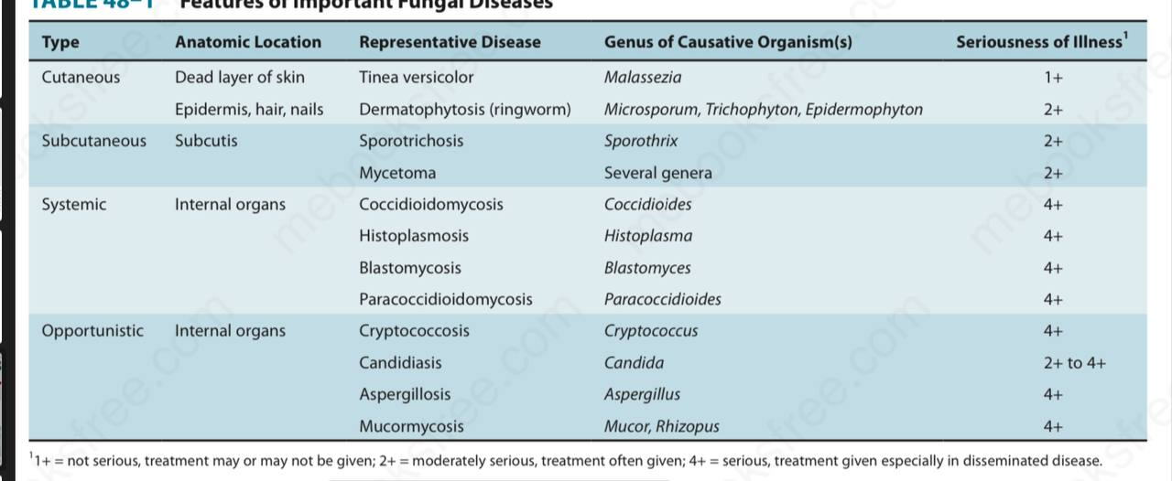
Medical mycoses can be divided into four categories: (1) cutaneous, (2) subcutaneous, (3) systemic, and (4) opportunistic.

CUTANEOUS MYCOSES
Dermatophytoses
Dermatophytoses are caused by fungi (dermatophytes) that infect only superficial keratinized structures (skin, hair, and nails), not deeper tissues. The most important dermatophytes are classified in three genera: Trichophyton, Epidermophyton, and Microsporum. They are spread from infected persons by direct contact. Microsporum is also spread from animals such as dogs and cats. This indicates that to prevent reinfection, the animal must be treated also. Dermatophytoses (tinea, ringworm) are chronic infections often located in the warm, humid areas of the body (e.g., athlete’s foot and jock itch).1 Typical ringworm lesions have an inflamed circular border containing papules and vesicles surrounding a clear area of relatively normal skin. The lesions are typically pruritic. Broken hairs and damaged nails are often seen. The disease is typically named for the affected body part (i.e., tinea capitis [head], tinea corporis [body], tinea cruris [groin], and tinea pedis [foot]). Tinea unguium, also called onychomycosis, is a disease of the nails, especially toe nails. The nails become thickened, broken, and discolored. Trichophyton tonsurans is the most common cause of outbreaks of tinea capitis in children and is the main cause of endothrix (inside the hair) infections. Trichophyton rubrum is also a very common cause of tinea capitis. Trichophyton schoenleinii is the cause of favus, a form of tinea capitis in which crusts are seen on the scalp. Trichophyton species also cause an inflammatory pustular lesion on the scalp called a kerion. The marked inflammation is caused by an intense T-cell–mediated reaction to the presence of the fungus. In some infected persons, hypersensitivity causes dermatophytid (“id”) reactions (e.g., vesicles on the fingers). Id lesions are a response to circulating fungal antigens; the lesions do not contain hyphae. Patients with tinea infections show positive skin tests with fungal extracts (e.g., trichophytin). Scrapings of skin or nail placed in 10% potassium hydroxide (KOH) on a glass slide show septate hyphae under microscopy. Cultures on Sabouraud’s agar at room temperature develop typical hyphae and conidia. Tinea capitis lesions caused by Microsporum species can be detected by seeing fluorescence when the lesions are exposed to ultraviolet light from a Wood’s lamp. Treatment involves local antifungal creams, such as (terbinafine (Lamisil), undecylenic acid (Desenex), miconazole (Micatin), or tolnaftate (Tinactin). Oral griseofulvin (Fulvicin) or oral itraconazole (Sporanox) can also be used. Tinea unguium can be treated with efinaconazole solution applied topically to the nails. Prevention centers on keeping skin dry and cool.
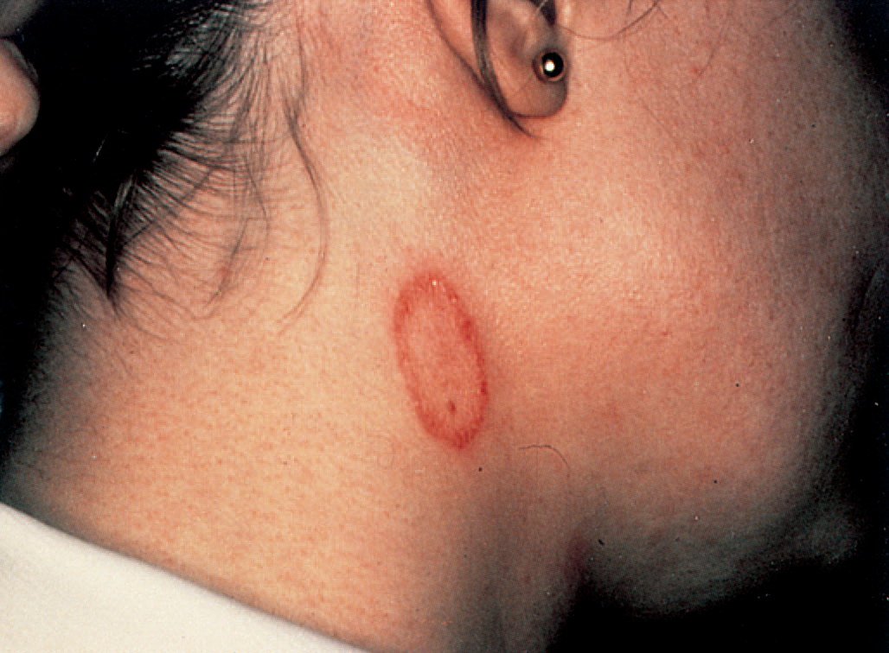
Tinea corporis (ringworm). Note oval, ring-shaped inflamed lesion with central clearing. Caused by dermatophytes such as Epidermophyton, Trichophyton, and Microsporum

Tinea Versicolor
Tinea versicolor (pityriasis versicolor), a superficial skin infection of cosmetic importance only, is caused by Malassezia species. The lesions are usually noticed as hypopigmented areas, especially on tanned skin in the summer. There may be slight scaling or itching, but usually the infection is asymptomatic. It occurs more frequently in hot, humid weather. The lesions contain both budding yeast cells and hyphae. Diagnosis is usually made by observing this mixture in KOH preparations of skin scrapings. Culture is not usually done. The treatment of choice is topical miconazole, but the lesions have a tendency to recur. Oral antifungal drugs, such as fluconazole or itraconazole, can be used to treat recurrences.
Tinea Nigra
Tinea nigra is an infection of the keratinized layers of the skin. It appears as a brownish spot caused by the melaninlike pigment in the hyphae. The causative organism, Cladosporium werneckii, is found in the soil and transmitted during injury. In the United States, the disease is seen in the southern states. Diagnosis is made by microscopic examination and culture of skin scrapings. The infection is treated with a topical keratolytic agent (e.g., salicylic acid).
SUBCUTANEOUS MYCOSES
These are caused by fungi that grow in soil and on vegetation and are introduced into subcutaneous tissue through trauma.
Sporotrichosis
Sporothrix schenckii is a dimorphic fungus. The mold form lives on plants, and the yeast form occurs in human tissue. When spores of the mold are introduced into the skin, typically by a thorn, it causes a local pustule or ulcer with nodules along the draining lymphatics. The lesions are typically painless, and there is little systemic illness. Untreated lesions may wax and wane for years.
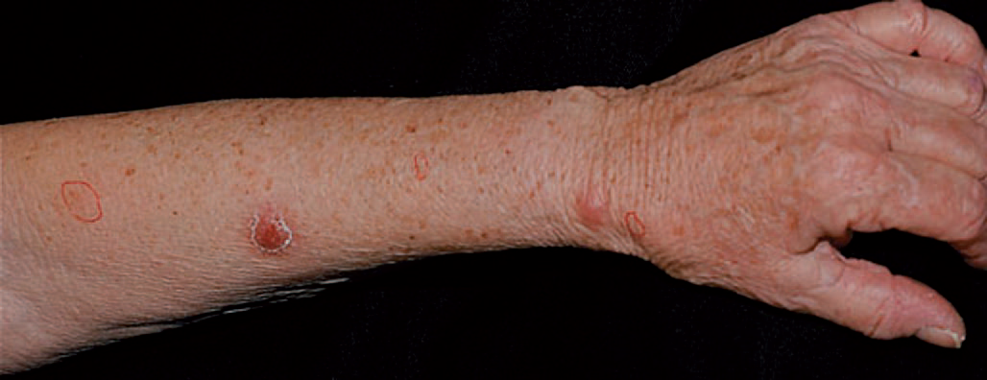
Sporotrichosis. Note papular lesions on left hand and forearm. Caused by Sporothrix schenckii

In human immunodeficiency virus (HIV)–infected patients with low CD4 counts, disseminated sporotrichosis can occur. Sporotrichosis occurs most often in gardeners, especially those who prune roses, because they may be stuck by a rose thorn. In the clinical laboratory, round or cigar-shaped budding yeasts are seen in tissue specimens. In culture at room temperature, hyphae occur bearing oval conidia in clusters at the tip of slender conidiophores (resembling a daisy). The drug of choice for skin lesions is itraconazole (Sporanox). It can be prevented by protecting skin when touching plants, moss, and wood.
Chromomycosis
This is a slowly progressive granulomatous infection that is caused by several soil fungi (Fonsecaea, Phialophora, Cladosporium, etc.) when introduced into the skin through trauma. These fungi are collectively called dematiaceous fungi, so named because their conidia or hyphae are darkcolored, either gray or black. Wartlike lesions with crusting abscesses extend along the lymphatics. The disease occurs mainly in the tropics and is found on bare feet and legs. In the clinical laboratory, dark brown, round fungal cells are seen in leukocytes or giant cells. The disease is treated with oral flucytosine or thiabendazole, plus local surgery.
Mycetoma
Soil fungi (Petriellidium, Madurella) enter through wounds on the feet, hands, or back and cause abscesses, with pus discharged through sinuses. The pus contains compact colored granules. Actinomycetes such as Nocardia can cause similar lesions (actinomycotic mycetoma). Sulfonamides may help the actinomycotic form. There is no effective drug against the fungal form; surgical excision is recommended.

SYSTEMIC MYCOSES
These infections result from inhalation of the spores of dimorphic fungi that have their mold forms in the soil. Within the lungs, the spores differentiate into yeasts or other specialized forms, such as spherules. Most lung infections are asymptomatic and self-limited. However, in some persons, disseminated disease develops in which the organisms grow in other organs, cause destructive lesions, and may result in death. Infected persons do not communicate these diseases to others.
COCCIDIOIDES
Disease
Coccidioides immitis causes coccidioidomycosis.
Properties
Coccodioides immitis is a dimorphic fungus that exists as a mold in soil and as a spherule in tissue.
Transmission & Epidemiology
The fungus is endemic in arid regions of the southwestern United States and Latin America. People who live in Central and Southern California, Arizona, New Mexico, Western Texas, and Northern Mexico, a geographic region called the Lower Sonoran Life Zone, are often infected. In soil, it forms hyphae with alternating arthrospores and empty cells. Arthrospores are very light and are carried by the wind. They can be inhaled and infect the lungs.
Laboratory Diagnosis
In tissue specimens, spherules are seen microscopically. Cultures on Sabouraud’s agar incubated at 25°C show septate hyphae with arthrospores . (Caution: Cultures are highly infectious; precautions against inhaling arthrospores must be taken.) In serologic tests, IgM and IgG precipitins appear within 2 to 4 weeks of infection and then decline in subsequent months. Complement-fixing antibodies occur at low titer initially, but the titer rises greatly if dissemination occurs. A PCR assay that detects nucleic acids of Coccidioides is available.
Treatment & Prevention
No treatment is needed in asymptomatic or mild primary infection. Amphotericin B (Fungizone) or itraconazole is used for persisting lung lesions or disseminated disease. Fluconazole is also effective in lung disease. If meningitis occurs, fluconazole is the drug of choice. Intrathecal amphotericin B may be required and may induce remission, but long-term results are often poor. There are no means of prevention except avoiding travel to endemic areas. Patients who have recovered from coccidioidal meningitis should receive long-term suppressive therapy with fluconazole to prevent a recurrence.
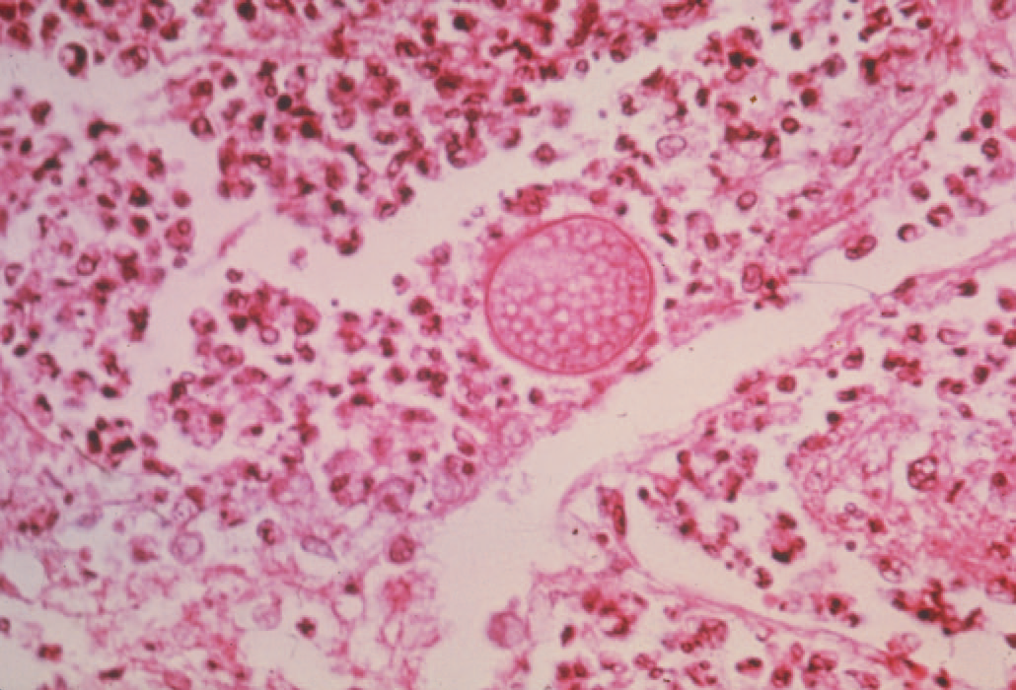
Coccidioides immitis—spherule. Long arrow points to a spherule in lung tissue. Spherules are large thick-walled structures containing many endospores. Short arrow points to an endospore
HISTOPLASMA
Histoplasma capsulatum causes histoplasmosis.
Properties
Histoplasma capsulatum is a dimorphic fungus that exists as a mold in soil and as a yeast in tissue. It forms two types of asexual spores (Figure 49–4): (1) tuberculate macroconidia, with typical thick walls and fingerlike projections that are important in laboratory identification; and (2) microconidia, which are smaller, thin, smooth-walled pores that, if inhaled, transmit the infection.
Transmission & Epidemiology
This fungus occurs in many parts of the world. In them United States, it is endemic in central and eastern states, especially in the Ohio and Mississippi River valleys. It grows in soil, particularly if the soil is heavily contaminated with bird droppings, especially from starlings. Although the birds are not infected, bats can be infected and can excrete the organism in their guano. In areas of endemic infection, excavation of the soil during construction or exploration of bat-infested caves has resulted in a significant number of infected individuals.
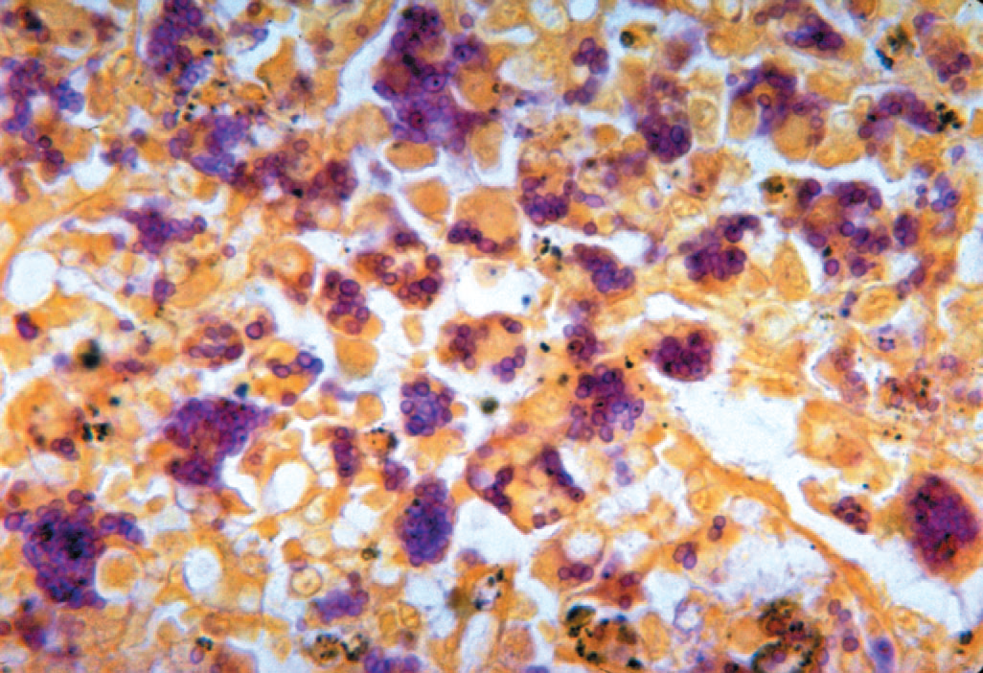
Histoplasma capsulatum—yeasts within macrophages.
Laboratory Diagnosis
In tissue biopsy specimens or bone marrow aspirates, oval yeast cells within macrophages are seen microscopically. Cultures on Sabouraud’s agar show hyphae with tuberculate macroconidia when grown at low temperature (e.g., 25°C) and yeasts when grown at 37°C. Tests that detect a Histoplasma polysaccharide antigen by enzyme-linked immunosorbent assay (ELISA) and Histoplasma RNA with DNA probes are also useful. In immunocompromised patients with disseminated disease, tests for Histoplasma antigen in the urine are especially useful because antibody tests may be negative.
Treatment & Prevention
No therapy is needed in asymptomatic or mild primary infections. With progressive lung lesions, oral itraconazole is effective. In disseminated disease, parenteral itraconazole (or amphotericin B) is the treatment of choice. Liposomal amphotericin B should be used in patients with preexisting kidney damage. In meningitis, fluconazole is often used because it penetrates the spinal fluid well. Oral itraconazole is used for chronic suppression in patients with AIDS.

BLASTOMYCES
Blastomyces dermatitidis causes blastomycosis, also known
as North American blastomycosis.
Properties
Blastomyces dermatitidis is a dimorphic fungus that exists as a mold in soil and as a yeast in tissue. The yeast is round with a doubly refractive wall and a single broad-based bud. Note that this organism forms a broad-based bud, whereas Cryptococcus neoformans is a yeast that forms a narrow-based bud.
Transmission & Epidemiology
This fungus is endemic primarily in eastern North America, especially in the region bordering the Ohio, Mississippi, and St. Lawrence rivers, and the Great Lakes region. Less commonly, blastomycosis has also occurred in Central and South America, Africa, and the Middle East. It grows in moist soil rich in organic material, forming hyphae with small pear-shaped conidia. Inhalation of the conidia causes human infection.
Pathogenesis & Clinical Findings
Infection occurs mainly via the respiratory tract. Asymptomatic or mild cases are rarely recognized. Dissemination may result in ulcerated granulomas of skin, bone, or other sites.
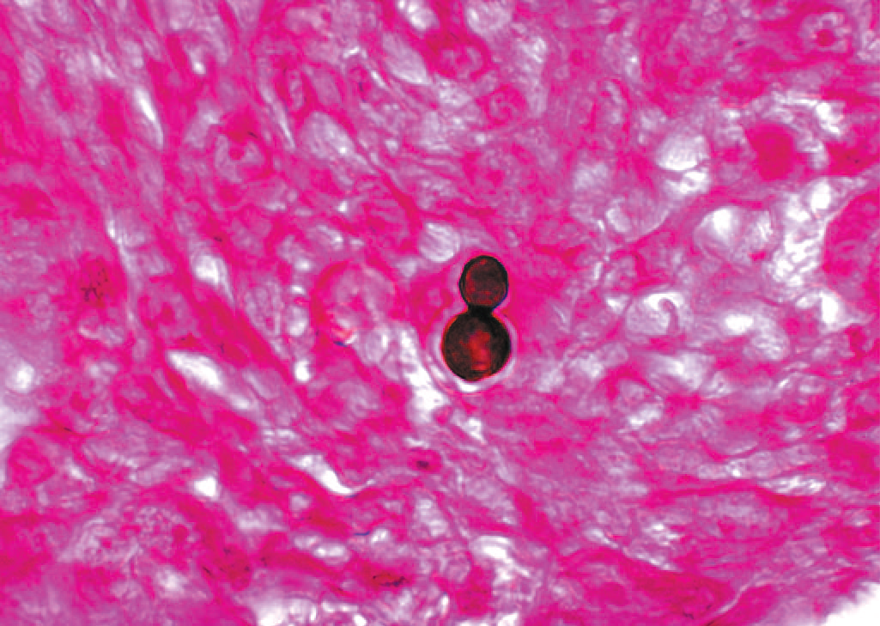
Laboratory Diagnosis
In tissue biopsy specimens, thick-walled yeast cells with single broad-based buds are seen microscopically/ Hyphae with small pear-shaped conidia are visible on culture. The skin test lacks specificity and has little value. Serologic tests have little value. A PCR assay that detects nucleic acids of Blastomyces is available.
Treatment & Prevention
Itraconazole is the drug of choice for most patients, but amphotericin B should be used to treat severe disease. Surgical excision may be helpful. There are no means of prevention.
PARACOCCIDIOIDES
Disease
Paracoccidioides brasiliensis causes paracoccidioidomycosis, also known as South American blastomycosis.
Properties
Paracoccidioides brasiliensis is a dimorphic fungus that exists as a mold in soil and as a yeast in tissue. The yeast is thick-walled with multiple buds, in contrast to B. dermatitidis, which has a single bud .
Transmission & Epidemiology
This fungus grows in the soil and is endemic in rural Latin America. Disease occurs only in that region.
Pathogenesis & Clinical Findings
The spores are inhaled, and early lesions occur in the lungs. Asymptomatic infection is common. Alternatively, oral mucous membrane lesions, lymph node enlargement, and sometimes dissemination to many organs develop.
Laboratory Diagnosis
In pus or tissues, yeast cells with multiple buds resembling a “ship captain’s wheel” are seen microscopically. A specimen cultured for 2 to 4 weeks may grow typical organisms. Skin tests are rarely helpful. Serologic testing shows that when significant antibody titers (by ID or CF) are found, active disease is present.
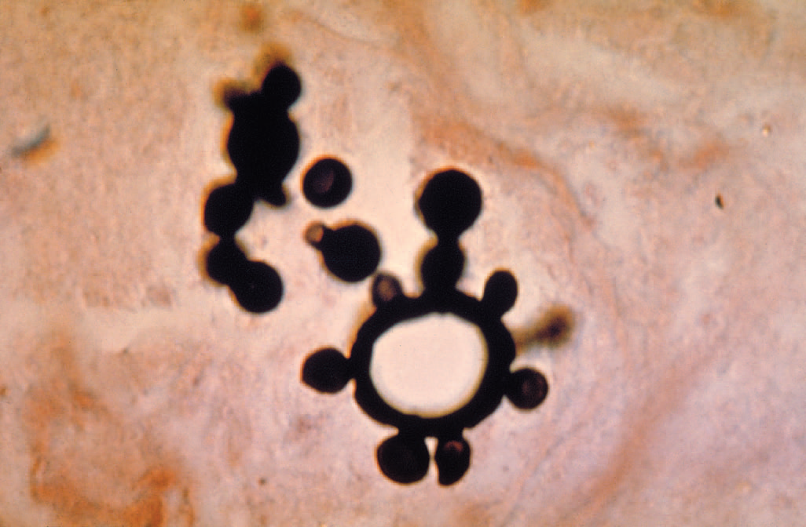
Paracoccidioides—yeasts with multiple buds resembling a “ship captain’s wheel.” Methenamine silver stain.

Treatment & Prevention
The drug of choice is itraconazole taken orally for several months. There are no means of prevention
OPPORTUNISTIC MYCOSES
Opportunistic fungi fail to induce disease in most immunocompetent persons but can do so in those with impaired host defenses. There are five genera of medically important fungi: Candida, Cryptococcus, Aspergillus, Mucor, and Rhizopus.
CANDIDA
Diseases
Candida albicans, the most important species of Candida, causes thrush, vaginitis, esophagitis, diaper rash, and chronic mucocutaneous candidiasis. It also causes disseminated infections such as right-sided endocarditis (especially in intravenous drug users), bloodstream infections (candidemia), and endophthalmitis. Infections related to indwelling intravenous and urinary catheters are also important. Candida glabrata is the second most common cause of disseminated candidal infections and is more drug resistant than C. albicans.
Properties
Candida albicans is an oval yeast with a single bud. It is part of the normal flora of mucous membranes of the upper respiratory, gastrointestinal, and female genital tracts. In tissues it appears most often as yeasts or as pseudohyphae. Pseudohyphae are elongated yeasts that visually resemble hyphae but are not true hyphae. True hyphae are also formed when C. albicans invades tissues. Carbohydrate fermentation reactions can be used to differentiate it from other species (e.g., Candida tropicalis, Candida parapsilosis, Candida krusei, and C. glabrata) that cause human infections. Candida dubliniensis is closely related to C. albicans. It also causes opportunistic infections in immunocompromised patients, especially AIDS patients. Both species form chlamydospores but C. albicans grows at 42°C whereas C. dubliniensis does not.
Transmission
As a member of the normal flora, C. albicans is already present on the skin and mucous membranes. In addition to the skin, C. albicans is found throughout the GI tract (especially the mouth and esophagus) and in the vagina. Thrush in the newborn is the result of passage through a birth canal heavily colonized by the organism. The presence of C. albicans on the skin predisposes to infections involving instruments that penetrate the skin, such as needles (intravenous drug use) and indwelling catheters. It is often found in the urine of patients with indwelling urinary (Foley) catheters.

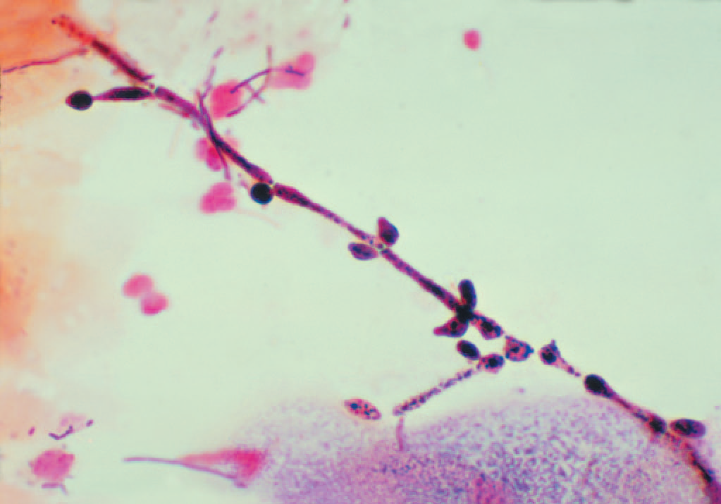
Candida albicans—pseudohyphae
Laboratory Diagnosis
In exudates or tissues, budding yeasts and pseudohyphae appear gram-positive and can be visualized by using calcofluor-white staining. In culture, typical yeast colonies are formed that resemble large staphylococcal colonies. Candida albicans forms germ tubes in serum at 37°C, whereas most other species of pathogenic Candida species do not . Chlamydospores are typically formed by C. albicans but not by most other species of Candida. Note that C. dubliniensis also forms chlamydospores but will not grow at 42°C whereas C. albicans will. Serologic testing is rarely helpful. A laboratory test that can identify C. albicans and four other Candida species in blood cultures in 3 to 5 hours instead of the usual several days was approved in 2014. The test uses magnetic resonance technology to detect the presence of yeast DNA and then to identify the species. Skin tests with Candida antigens are uniformly positive in immunocompetent adults and are used as an indicator that the person can mount a cellular immune response. A person who does not respond to Candida antigens in the skin test is presumed to have deficient cell-mediated immunity. Such a person is anergic, and other skin tests cannot be interpreted. Thus if a person has a negative Candida skin test, a negative purified protein derivative (PPD) skin test for tuberculosis could be a false-negative result.
CRYPTOCOCCUS
Disease
Cryptococcus neoformans causes cryptococcosis, especially cryptococcal meningitis. Cryptococcosis is the most common, life-threatening invasive fungal disease worldwide. It is especially important in AIDS patients. Another species, Cryptococcus gattii, causes human disease less frequently than C. neoformans.
Properties
Cryptococcus neoformans is an oval, budding yeast surrounded by a wide polysaccharide capsule . It is not dimorphic. Note that this organism forms a narrow-based bud, whereas the yeast form of Blastomyces dermatitidis forms a broad-based bud.
Transmission
Cryptococcus neoformans occurs widely in nature and grows abundantly in soil containing bird (especially pigeon) droppings. The birds are not infected. Human infection results from inhalation of the organism. There is no human-to-human transmission. Cryptococcus gattii is associated with eucalyptus trees, most often in the northwestern states of the United States. It is also found in subtropical and tropical areas of many countries.
Pathogenesis & Clinical Findings
Lung infection is often asymptomatic or may produce pneumonia. Disease caused by C. neoformans occurs mainly in patients with reduced cell-mediated immunity, especially AIDS patients, in whom the organism disseminates to the central nervous system (meningitis) and other organs. Subcutaneous nodules are often seen in disseminated disease. Note, however, that roughly half the patients with cryptococcal meningitis fail to show evidence of immunosuppression. In some patients with AIDS who are infected with Cryptococcus, treating the patient with highly active antiretroviral therapy (HAART) causes an exacerbation of symptoms.
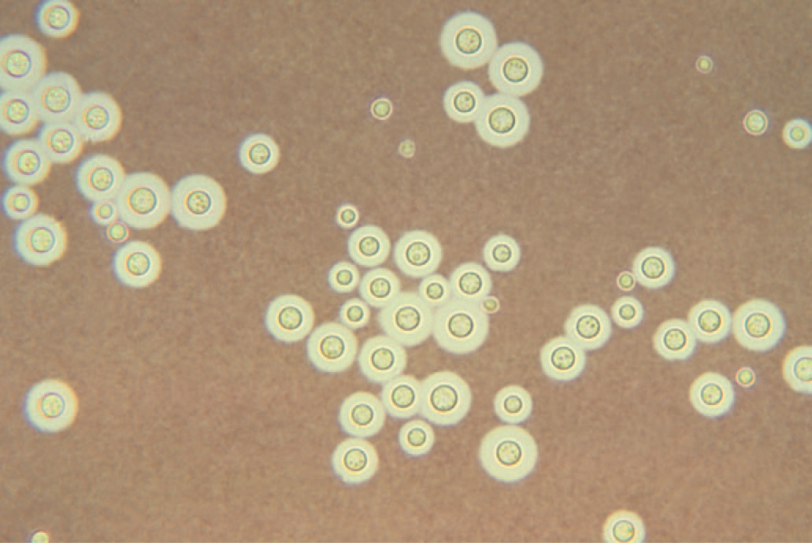
Cryptococcus neoformans—India ink preparation.

Laboratory Diagnosis
In spinal fluid mixed with India ink, the yeast cell is seen microscopically surrounded by a wide, unstained capsule. Appearance of the organism in Gram stain is unreliable,but stains such as periodic acid–Schiff (PAS stain), methenaminemsilver, and mucicarmine will allow the organism to be visualized . The organism can be cultured from spinal fluid and other specimens. The colonies are highly mucoid—a reflection of the large amount of capsular polysaccharide produced by the organism. Serologic tests can be done for both antibody and antigen. In infected spinal fluid, capsular antigen occurs in high titer and can be detected by the latex particle agglutination test. This test is called the cryptococcal antigen test, often abbreviated as “crag.” Distinguishing between C. neoformans and C. gattii in the laboratory requires specialized media not generally available, so many C. gattii infections may go undiagnosed.
Treatment & Prevention
Combined treatment with amphotericin B and flucytosine is used in meningitis and other disseminated disease. Liposomal amphotericin B should be used in patients with preexisting kidney damage. There are no specific means of prevention. Fluconazole is used in AIDS patients for longterm suppression of cryptococcal meningitis. Cryptococcus gattii is less responsive to antifungal drugs than is C. neoformans.
ASPERGILLUS
Disease
Aspergillus species, especially Aspergillus fumigatus, cause infections of the skin, eyes, ears, and other organs; “fungus ball” in the lungs; and allergic bronchopulmonary aspergillosis.
Properties
Aspergillus species exist only as molds; they are not dimorphic. They have septate hyphae that form V-shaped (dichotomous) branches . The walls are more or less parallel, in contrast to Mucor and Rhizopus walls, which are irregular . The conidia of Aspergillus form radiating chains, in contrast to those of Mucor and Rhizopus, which are enclosed within a sporangium.
Transmission
These molds are widely distributed in nature. They grow on decaying vegetation, producing chains of conidia. Transmission is by airborne conidia.
Pathogenesis & Clinical Findings
Aspergillus fumigatus can colonize and later invade abraded skin, wounds, burns, the cornea, the external ear, or paranasal sinuses. It is the most common cause of fungal sinusitis. In immunocompromised persons, especially those with neutropenia, it can invade the lungs producing hemoptysis and the brain causing an abscess. Neutropenic patients are also predisposed to intravenous catheter infections caused by this organism. In 2012, an outbreak of A. fumigatus infections, especially meningitis, occurred caused by injectable corticosteroid solutions that were contaminated with the fungus. Aspergilli are well-known for their ability to grow in cavities within the lungs, especially cavities caused by tuberculosis. Within the cavities, they produce an aspergilloma (fungus ball), which can be seen on chest X-ray as a radiopaque structure that changes its position when the patient is moved from an erect to a supine position. Allergic bronchopulmonary aspergillosis (ABPA) is a hypersensitivity reaction to the presence of Aspergillus in the bronchi. Patients with ABPA have asthmatic symptoms and a high IgE titer against Aspergillus antigens, and they expectorate brownish bronchial plugs containing hyphae. Asthma caused by the inhalation of airborne conidia, especially in certain occupational settings, also occurs. Aspergillus flavus growing on cereals or nuts produces aflatoxins that may be carcinogenic or acutely toxic.
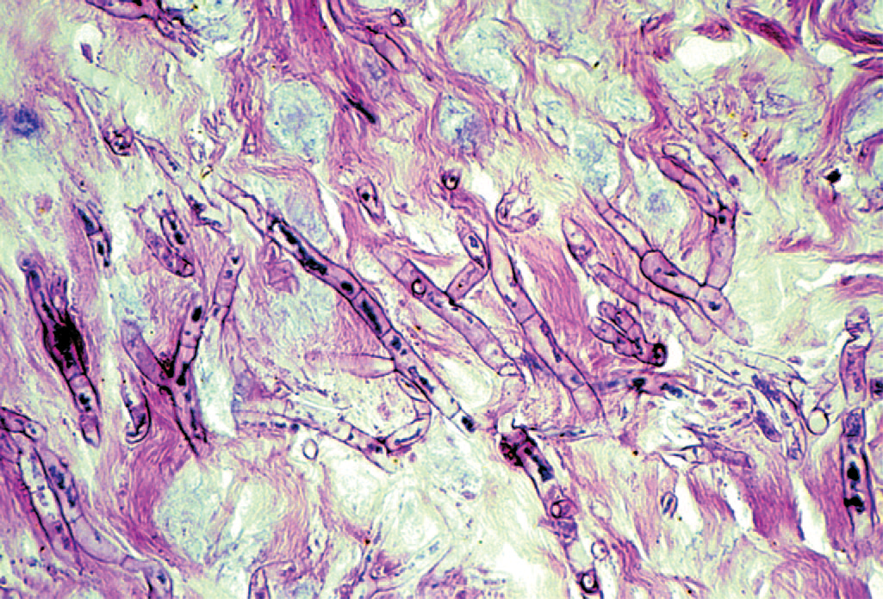
Laboratory Diagnosis
Biopsy specimens show septate, branching hyphae invading tissue . Cultures show colonies with characteristic radiating chains of conidia . However, positive cultures do not prove disease because colonization is common. In persons with invasive aspergillosis, there may be high titers of galactomannan antigen in serum. Patients with ABPA have high levels of IgE specific for Aspergillus antigens and prominent eosinophilia. IgG precipitins are also present.
Treatment & Prevention
Voriconazole is the drug of choice for invasive aspergillosis. Liposomal amphotericin B, posaconazole, and caspofungin are alternative drugs. A fungus ball growing in a sinus or in a pulmonary cavity can be surgically removed. Patients with ABPA can be treated with corticosteroids and antifungal agents, such as itraconazole. There are no specific means of prevention.
MUCOR & RHIZOPUS
Mucormycosis (zygomycosis, phycomycosis) is a disease caused by saprophytic molds (e.g., Mucor, Rhizopus, and Absidia) found widely in the environment. They are not dimorphic. These organisms are transmitted by airborne asexual spores and invade tissues of patients with reduced host defenses. They proliferate in the walls of blood vessels, particularly of the paranasal sinuses, lungs, or gut, and cause infarction and necrosis of tissue distal to the blocked vessel . Patients with diabetic ketoacidosis, burns, bone marrow transplants, or leukemia are particularly susceptible. Diabetic patients are particularly susceptible to rhinocerebral mucormycosis, in which mold spores in the sinuses germinate to form hyphae that invade blood vessels that supply the brain. One species, Rhizopus oryzae, causes about 60% of cases of mucormycosis. In biopsy specimens, organisms are seen microscopically as nonseptate hyphae with broad, irregular walls and branches that form more or less at right angles . Cultures show colonies with spores contained within a sporangium. These organisms are difficult to culture because they are a single, very long cell, and damage to any part of the cell can limit its ability to grow. If diagnosis is made early, treatment of the underlying disorder, plus administration of amphotericin B and surgical removal of necrotic infected tissue, has resulted in some remissions and cures. Liposomal amphotericin B should be used in patients with preexisting kidney damage. Posaconazole can also be used.

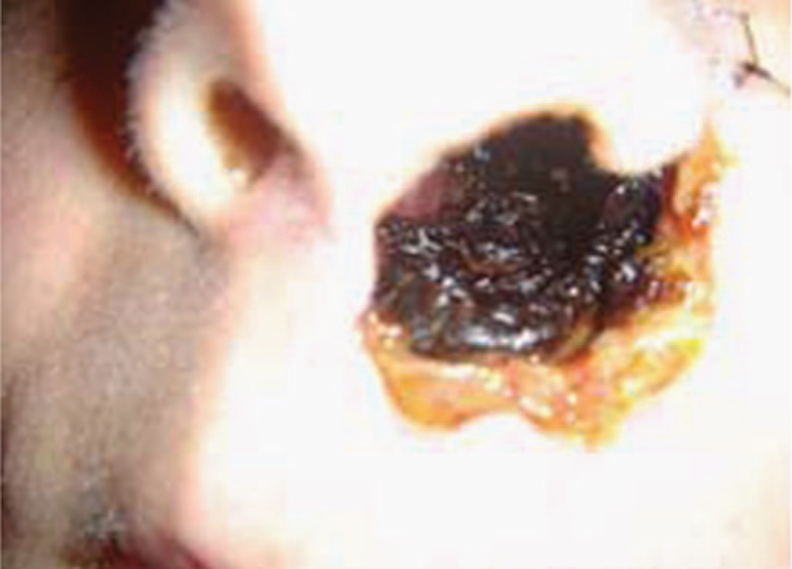
Mucor species—mucormycosis. Note necrotic area involving the nose and face

PNEUMOCYSTIS
Pneumocystis jiroveci is classified as a yeast on the basis of molecular analysis, but it has many characteristics of a protozoan. Some regard it as an “unclassified” organism.In 2002, taxonomists renamed the human species of Pneumocystis as P. jiroveci and recommended that P. carinii be used only to describe the rat species of Pneumocystis. Pneumocystis is acquired by inhalation of airborne organisms into the lungs. An inflammatory exudate composed primarily of plasma cells occurs, oxygen exchange is reduced, and dyspnea occurs. A reduced number of CD 4-postive T lymphocytes, such as occurs in AIDS, predisposes to pneumonia. Most immunocompetent people have asymptomatic infections. The clinical findings of Pneumocystis pneumonia include fever, nonproductive cough, and dyspnea. Rales are heard bilaterally and the chest X-ray shows a “groundglass” pattern. The mortality rate of untreated Pneumocystis pneumonia is approximately 100%.

